|  |  |
| --- | --- |
| **Team ID** | PNT2022TMID31893 |
| **Project Name** | **Project -Hazardous area monitoring for industrial plant powered by IoT** |

# Creating NODE-RED Service

* Node-RED is a flow-based development tool for visual programming developed originally by IBM for wiring together hardware devices, APIs and online services as part of

the Internet of Things.

* Node-RED provides a web browser-based flow editor, which can be used to create JavaScript functions. Elements of applications can be saved or shared for re-use.
* The runtime is built on Node.js.
* The flows created in Node-RED are stored using JSON.

# Social Development:

* The flows created in Node-RED are stored using JSON which can be easily imported and exported for sharing with others.
* An online flow library allows you to share your best flows with the world.

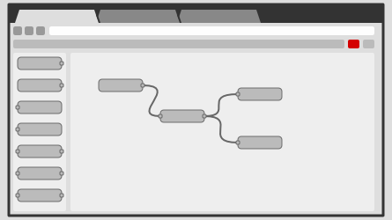

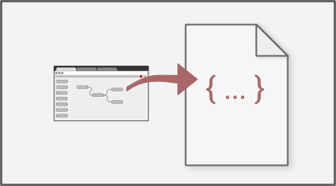

**Step1:** go to nodejs website and download .msi file in downloads page.

**Step2:**run the .msi file and install the nodejs.

**Step3:** install nodered in command prompt: npm install -g --unsafe- perm node-red

**Step4:** type node-red in cmd and u will get the local server link, just open it.

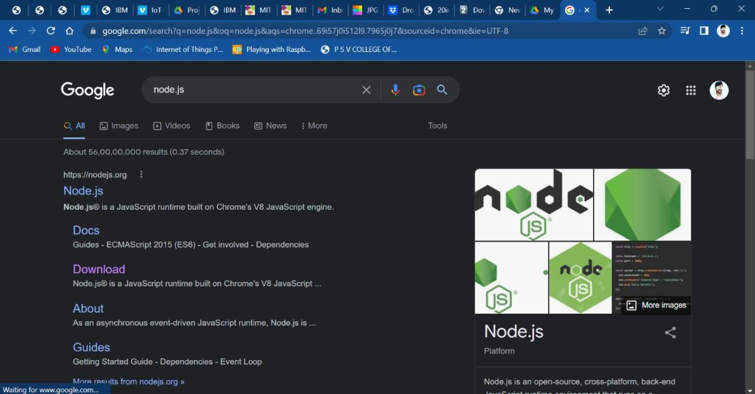

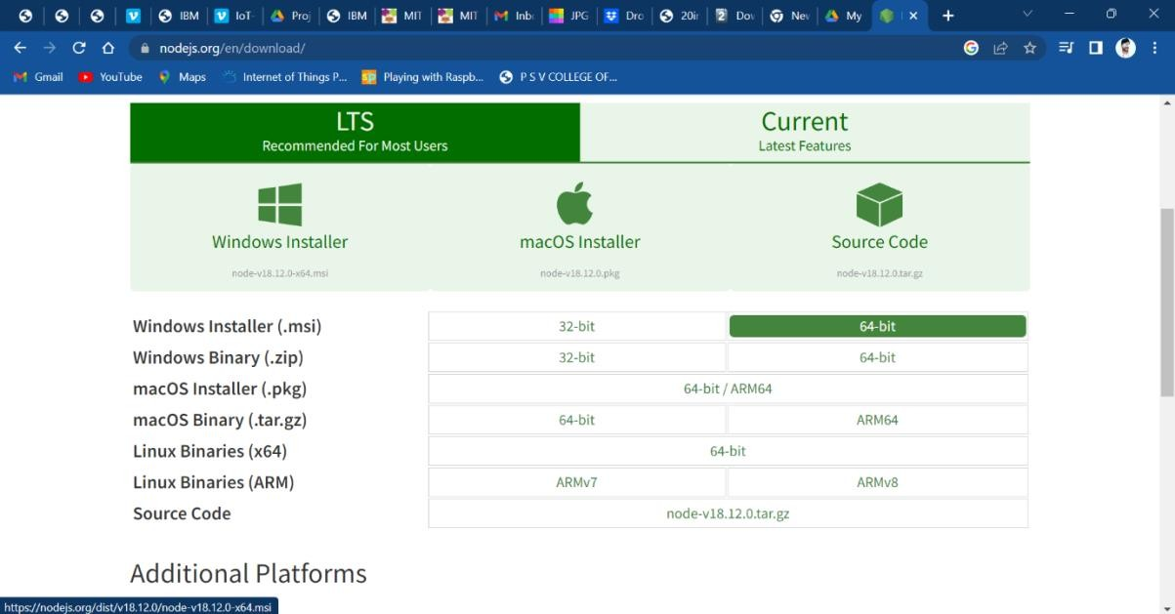

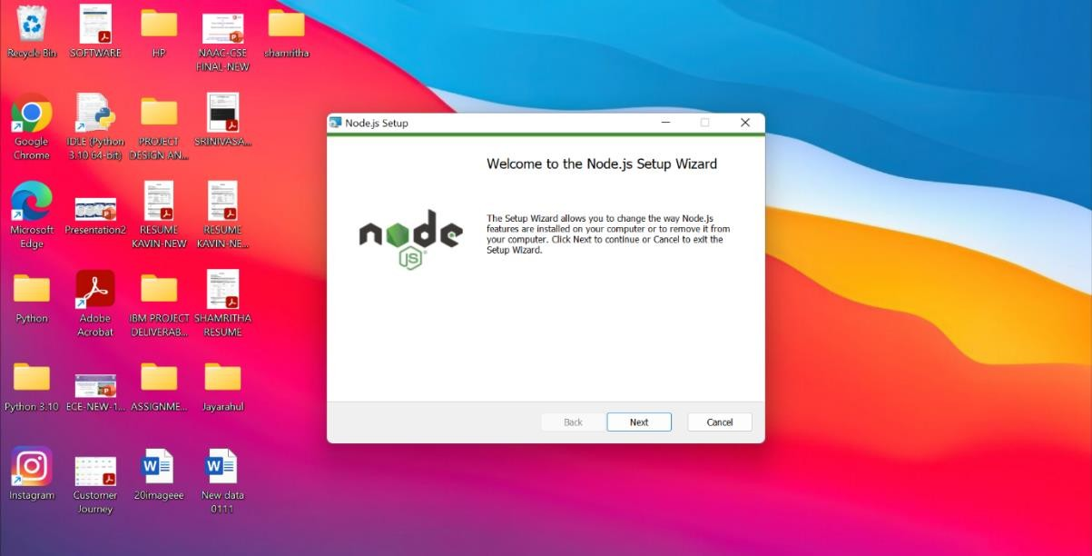

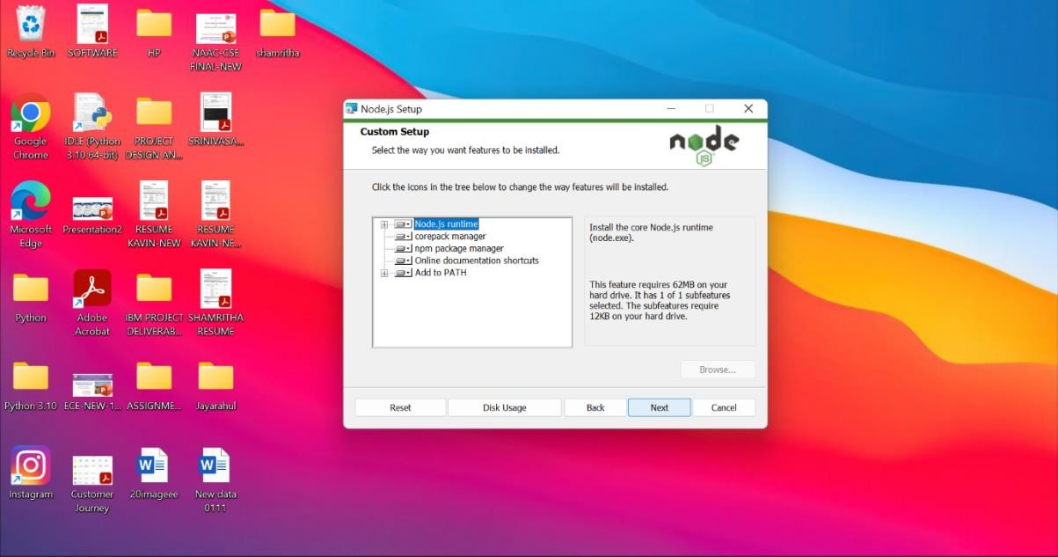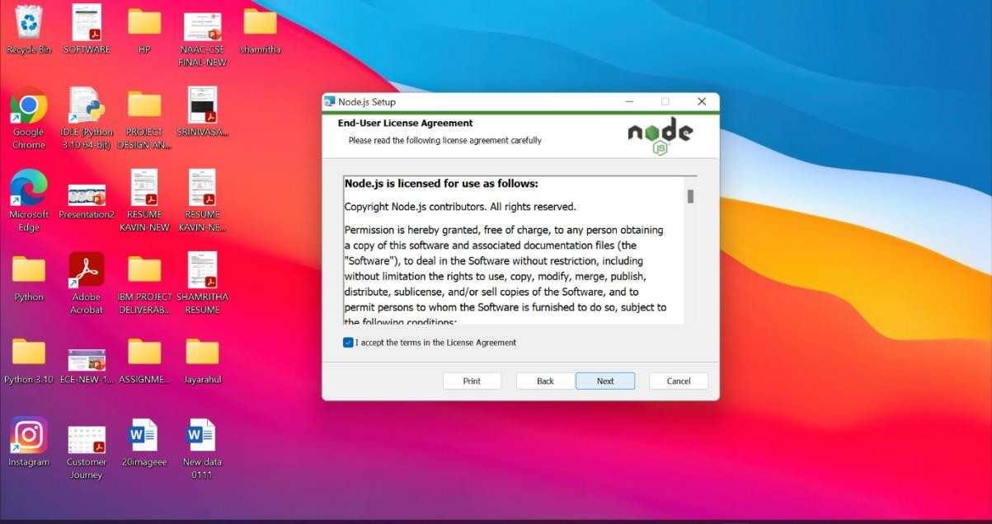

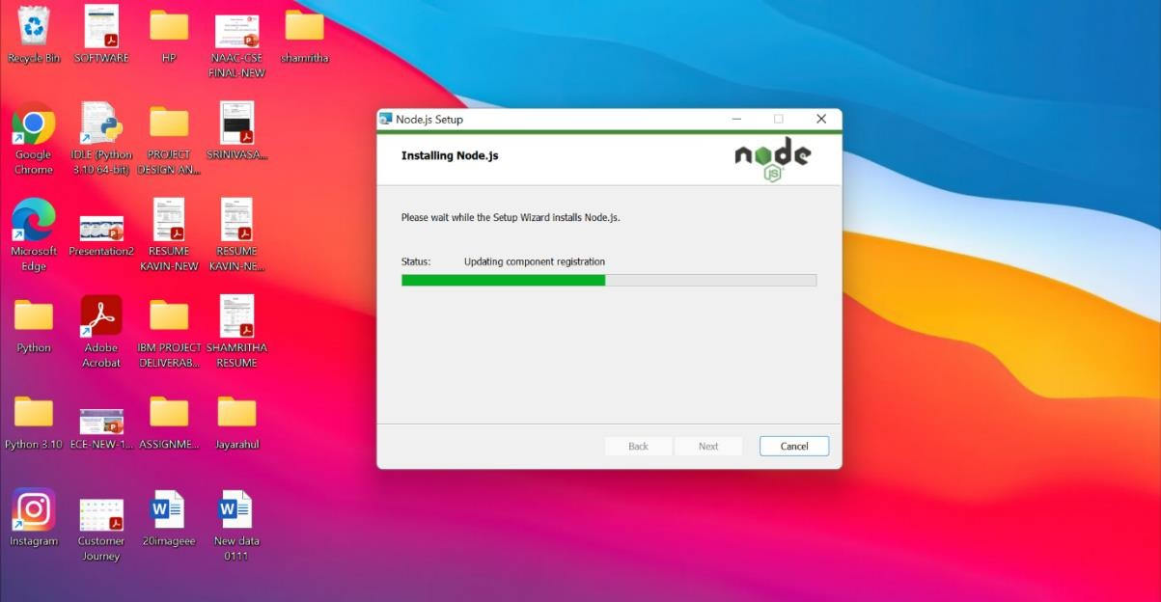

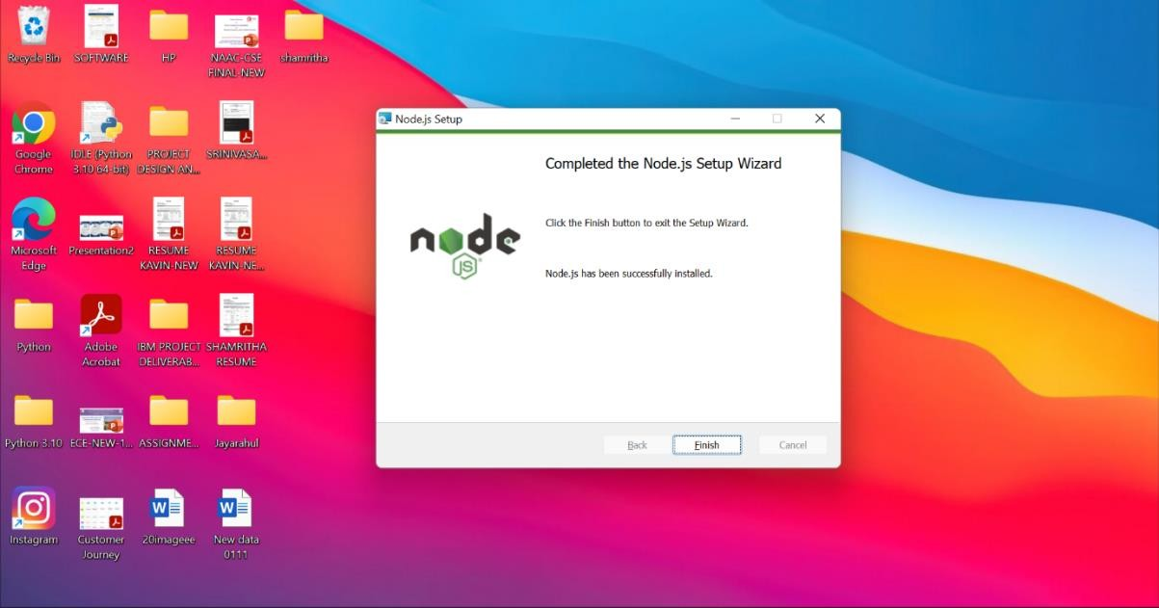

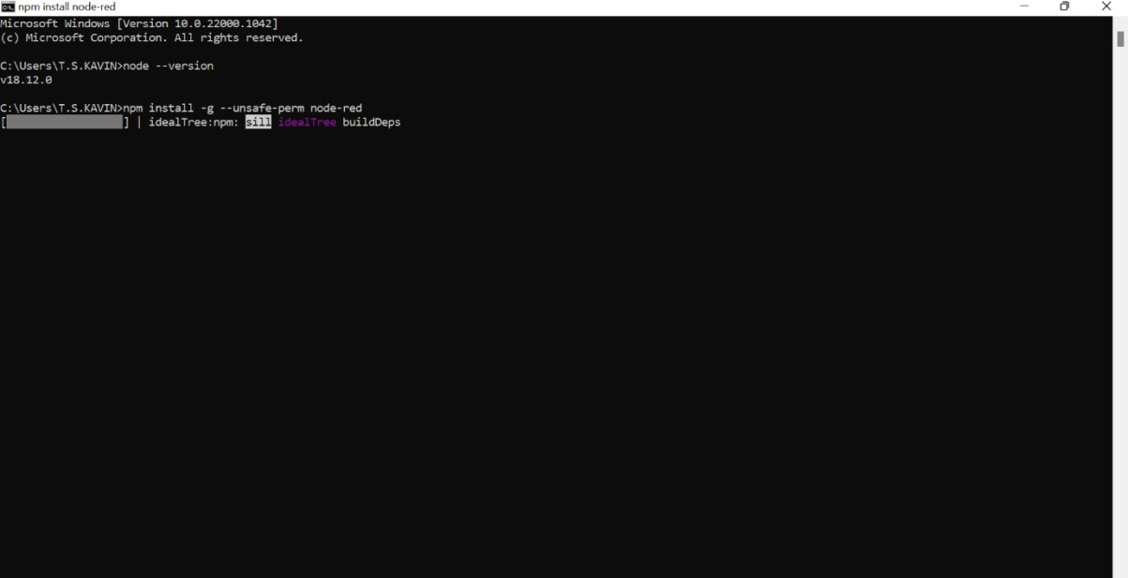

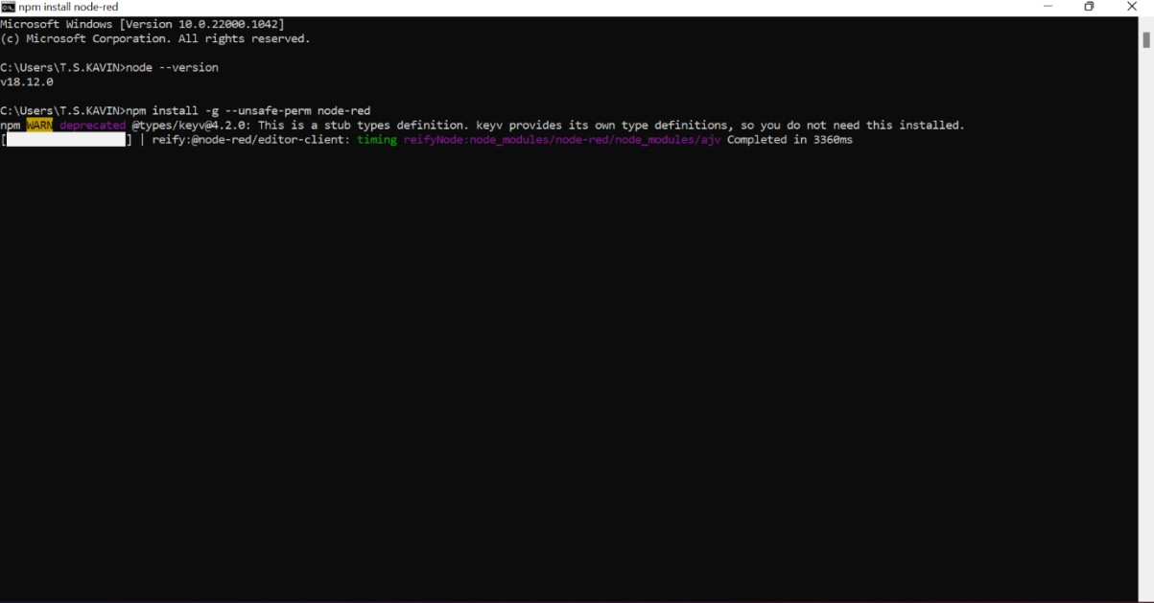

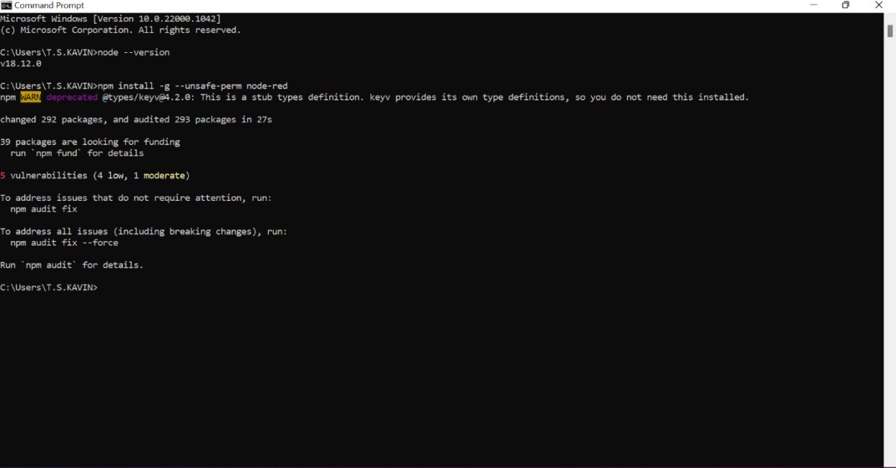

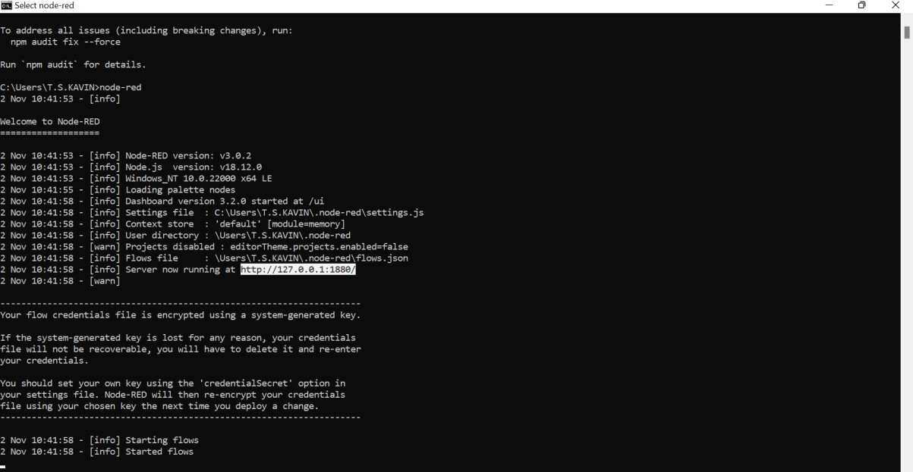

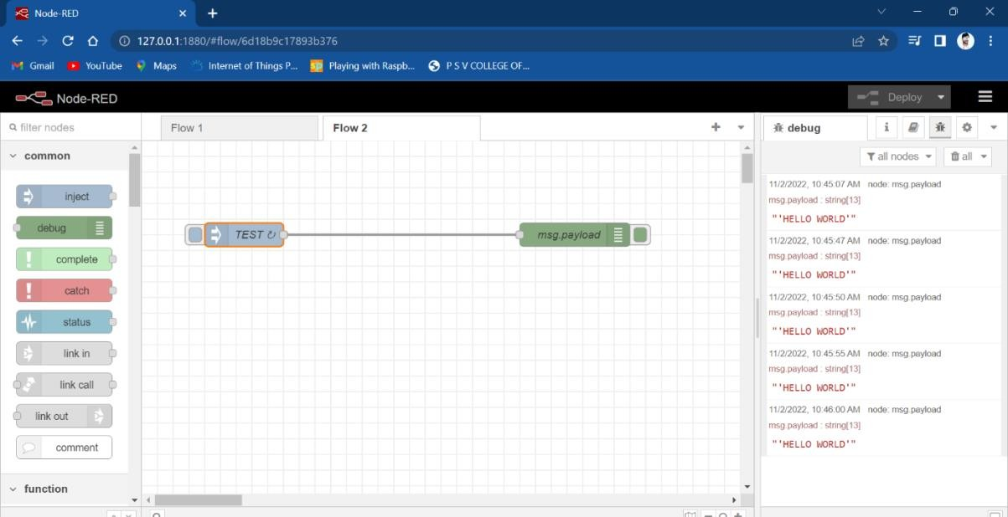

# Thus we created NODE-RED Service.